Modern physics – A popular science article

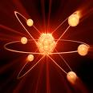
Written part:
You shall write a popular science article. The article has two parts.
- How does physicists use models?
Examples:
- What does a model describes?
- Are models correct pictures of reality?
- Witch models do we use? And who is using them?
- How has the models changed thru history?

- Choose one of the scientific areas below and write about it.
- Strong interaction
- Weak interaction
- Electromagnetic force
- The higgs particle
- Gravity/Theory of relativity

Oral part:
You shall together with other, who choose the same area as you, make a presentation for the class. Powerpoint or similar software are required.

